Types of optional parameters
Workshop #4
Flutter Developer Bootcamp

Purpose
This workshop demonstrates the different ways of passing parameters to functions: using positional parameters and named parameters.

Problem
In the given workshop demonstrates how functions handle parameter passing using both positional and named parameters.
- Positional Parameters:
- PositionedParameters('Parameter 1', 'parameter 2'); passes two arguments directly.
- PositionedParameters('Parameter 1'); demonstrates optional parameters where the second argument (two) can be omitted.
- Named Parameters:
- NamedParameters(two: 'parameter 2', one: 'parameter 1'); uses named parameters, allowing arguments to be passed in any order by specifying their names.
This example showcases Dart's flexibility in parameter handling, supporting both positional and named parameters to enhance code clarity and maintainability.
You need to print Default parameter:
- Parameter one : parameter 1
- Parameter two : ‘hyy’
- Parameter one : parameter 1
- Parameter two : parameter 2

How to Solve
- Checkout the workshop from Git Repo:
git clone -b <user-branch> <repo-URL>
- Open the root folder inside VS Code
- Open the root folder in terminal
- Run the command dart run filename.dart
- PositionedParameters Function:
- Accepts a required positional parameter one of type String.
- Optionally accepts a positional parameter two of type String?.
- Prints "Default parameter:" as an introductory message.
- Displays the values of parameters one and two.
- NamedParameters Function:
- Accepts named parameters one and two of type String?.
- Prints the values of named parameters one and two.
- Main Function Execution:
- Invokes PositionedParameters with two positional arguments, 'parameter 1' and 'hyy'.
- Outputs the values of parameters one and two.
- Invokes NamedParameters with named arguments one: 'parameter 1' and two: 'parameter 2'.
- Outputs the values of named parameters one and two.
- Go To File: <specific-file--method> à <method-name>, implement your logic.

You will Achieve
When you complete this workshop you will learn the following:

Methods and Functions Used:

- PositionedParameters Function:
- void PositionedParameters(String one, [String? two])
- Handles positional parameters where:
- one is a required parameter of type String.
- two is an optional parameter of type String?.
- Prints a message "Default parameter:" followed by the values of one and two.
- NamedParameters Function:
- void NamedParameters({String? one, String? two})
- Demonstrates named parameters:
- one and two are optional named parameters of type String?.
- Prints the values of named parameters one and two.
- Main Function:
- Calls PositionedParameters('parameter 1', 'hyy'); to demonstrate positional parameter handling and output.
- Calls NamedParameters(one: 'parameter 1', two: 'parameter 2'); to demonstrate named parameter handling and output.

Screenshots

Before implementation (without printing default parameter)

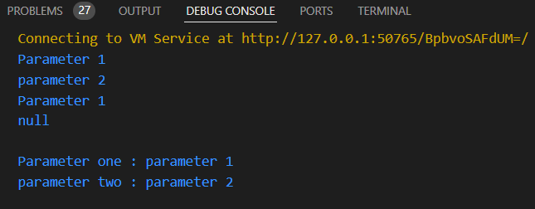

After implementation (with printing default parameter)

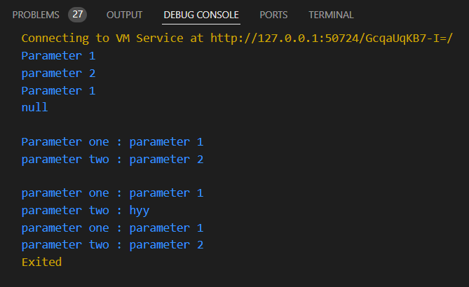

How to submit your workshop
Push your project back to the same git branch using command:
<command name>

Happy Coding!

